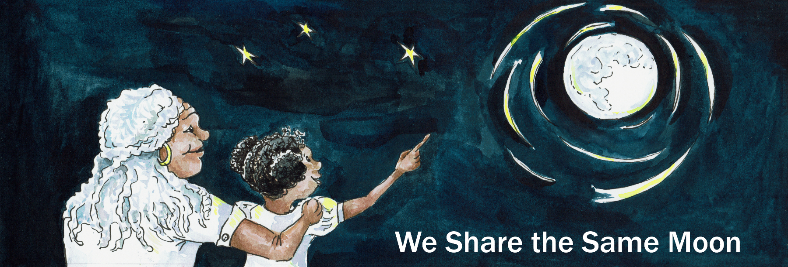
Suggested Age Range: 7 - 8 years: 8 - 9 years; 9 - 10 years; 10 - 11 years
UK Curriculum: Key Stage Two (Upper)
Suggested UK Year Group: Year 6
UK Primary Curriculum Link: Evolution and Inheritance
Science Subject: Evolution
Science Question: How do organisms evolve?
Suggested Science Activity: Evolution
Children with SEND: Use to boost comprehension of science vocabulary
EAL children: For Beginners
Country of Origin:Vietnam
Source: How Tiger Got His Stripes by Baird Hoffmire and Rob Cleveland

Long ago in the rainforests of Vietnam …
The proudest animal of all - was NOT the Lion!
The most beautiful animal of all - was NOT the Peacock!
The strongest animal of all - was NOT the Elephant!
The most beautiful, the most proudest, the most strongest was … Tiger!

Tiger, with his long fangs, sharp claws and golden coat was King of the forest!
Whatever he said, all the other animals would agree.
No-body ever dared disagree with him!
Except for Water Buffalo, who was bigger than Tiger and had long sharp horns of his own!
Tiger loved being King, he loved to stroll through the forest and have all the other animals bow down to him.

But, it annoyed him that Water Buffalo, of all the animals never seemed to listen to him. He was too big for Tiger to fight, but secretly Tiger wished and wished there was a way to make Water Buffalo obey him!

One day, Tiger was strolling through the dappled green forest, admiring the shade on his beautiful golden skin, when suddenly he stopped and stared. The forest had gone!
Where there had once been trees - there was now just mud.
And someone had made holes in the mud and was planting strange strands of grass into the ground! What was going on?

Tiger hid behind a bush, and waited.
Then, to his amazement, Water Buffalo appeared. But not on his own!
He had something tied to him, that was making holes in the ground!
And leading him, was a strange two legged animal that tiger had never seen before! The two legged animal was telling Water Buffalo was to do!
And, stranger still, Water Buffalo was obeying him.
Tiger could not believe what he saw!
Water Buffalo was actually obeying this tiny little creature!
How could this be?
What secret did this little animal know that Tiger didn’t, to make water buffalo obey him?

He waited, until the end of the day, when Water Buffalo finished working and went down to the river to drink. And there was Tiger waiting for him.
“Water Buffalo! I saw you today - working for that tiny little two legged creature. You did whatever he asked you to do! Why? Why do you work for him? Why do you obey him?”
Water Buffalo looked thoughtfully at Tiger:
“The little creature is called Man. And I obey him because he has Wisdom”.
“This is something, you Tiger, do not have and never will!”
“Hah!” said Tiger furiously. “I will get this wisdom too! I will make Man give it to me! And you will have to obey me!”

So, the next day, Tiger hid, by the edge of the forest, behind a tree.
He saw the field where Buffalo had been working and at the edge of the field was a strange building. Tiger had never seen a house before, animals do not build them. But, Water Buffalo had said that this was what Man did.
Out of this thing called a house came the Man.
The man was leading some goats, they looked very tasty to Tiger.
The man led the goats through the grass, right to where Tiger was hiding!

Tiger was sprang out from his hiding place with a roar!
“Man, give me Wisdom!” He growled and flexed his claws!

Man shivered with fear.
“ Oh yes, Tiger I will give you anything! Wisdom you say you want - you shall have it immediately! I will just go to my house over there and find it!
You can come to the house with me! Oh but no, you are too big to et through the door …
What shall I do? I know! I will bring it to you! Just you wait here Tiger, whilst I fetch it!”

Tiger agreed, the Man turned as if to walk away, but then he stopped all of a sudden!
“Oh but no - if I leave you here with the goats you might eat them …
What shall I do? I know! I will tie your tail to a tree, to save you giving into temptation!”

Tiger agreed! He so wanted wisdom! The Man took a rope that was coiled around his waist and tied the tip of Tiger’s tail to a tree.

The Man turned as if to walk away, but then he stopped, all of a sudden!
“Oh but no - you are too strong you could easily break free! Oh, what shall I do?
I know! I shall tie all of your body to the tree.

Tiger agreed! He so wanted wisdom!”
The Man took the rope and tied it round and around Tiger’s body, so that he was trapped against the tree.

The Man turned as if to walk away, but then he stopped all of a sudden!
“Oh but no, you are the strongest animal of all!
With your sharp teeth, you could easily snap the ropes and break free!
Oh dearie, dearie, dearie me - what shall I do?
I know! Of course! I shall tied your head to the tree!

Tiger agreed. He so wanted wisdom that he allowed his head to be tied to the tree! He could barely see Man leave to get his wisdom.

The hours passed, the Sun shone down.
He could feel the ropes burning into skin.And what is more, he was hungry!
He could smell the goats, he could hear the goats, he could almost taste the goats, but could he break free! No!

The day passed, the Sun shone down.
He could feel the ropes burning and burning into skin.
And what is more - he was ravenous! Where was Man?
He lifted his head just a little, to peer around.
But in the dark, he could see nothing.

It was no use. He could not wait for wisdom! He needed to break free now!
He lifted his head as high as he could and began to gnaw the ropes. Weakened by pain, tiredness and hunger, it took him a long time.
But finally the rope began to give way - and with a giant heave, the rope snapped and Tiger fell free.

He was very, very hungry and very, very thirsty!
He staggered down to the river -bank to get a drink..
And there by the light of the Moon, as he bent his head to drink he saw …
Argh! A strange face looked up at him from the water.
A face with fangs, whiskers, golden skin and stripes!
Stripes! Could this be him? Tiger looked down at himself with horror!

Where he had been tied to the tree all day, the ropes had burnt into his skin.
He was covered in big stripes where the ropes had been!
Oh no! Tiger could not believe it!

Just then he heard the voice of Water Buffalo:
I told you Tiger - you would never find wisdom!

And from that Tiger, Tiger no longer strolls through the forest as if he owns it.
He slinks from bush to bush as if embarrassed by the stripes and the memory of being outwitted by Man.

Or at least that is what the people of Vietnam say …

But scientists say …

The real reason Tigers have stripes is so that they can hide from their prey!

Tigers eat Deer and other forest animals that are Red-Green colour blind.
To a Deer, a Tiger looks the same colour as the bushes he hides in.
And so Tiger is able to creep closer and closer and closer to the Deer until the Deer is … lunch! So maybe a Tiger does have wisdom after all!

What do YOU think?

Copyright: Cassandra Wye 2019

